

24ADC001- BUSINESS INTELLIGENCE

--------------------------------------------------

2026-2027
LAB RECORD

DEPARTMENT OF ARTIFICIAL
INTELLIGENCE AND DATA SCIENCE

INDEX
Expt. No | Title of the Experiment | Page No | Total  Marks | Faculty Signature
1. | Explore the interface and basic features of the BI tool
2. | Load and visualize a sample dataset.
3. | Import a dataset into the BI tool. And Cleanse data by handling missing values, outliers, and inconsistencies.
4. | Transform data to suit BI reporting requirements and Design a dashboard with key performance indicators (KPIs).
5. | Develop interactive dashboards for dynamic data exploration.
6. | Integrate data from various sources for comprehensive analysis
7. | Implement advanced chart types (treemaps, heatmaps, etc.).
8. | Apply BI tools for forecasting and predictive analytics.

Average marks Faculty Signature

EXPT NO:1 | EXPLORE THE INTERFACE AND BASIC FEATURES OF BI Tool
DATE: 10.07.2026

PRE-LAB QUESTIONS (PROVIDE BRIEF ANSWERS TO THE FOLLOWING QUESTIONS)

1. What is the purpose of Business Intelligence (BI) tools like Tableau and Power BI?
BI tools help organizations collect, process, analyze, and visualize data to support faster, data-driven decision-making. They convert raw data into interactive dashboards and reports that reveal trends, patterns, and insights.

2. List any three common data sources that Tableau and Power BI can connect to.
Excel/CSV files, SQL Server databases, and cloud sources like Google Analytics or Azure/SharePoint.

3. What is a dashboard in BI, and how is it different from a single chart?
A dashboard is a collection of multiple visualizations, charts, and KPIs combined on one screen to give a complete overview of data. A single chart shows only one metric or relationship, while a dashboard integrates many charts with shared filters for a holistic view.

4. Define the following terms:
a) Visualization – A graphical representation of data (charts, graphs, maps) used to make patterns easier to understand.
b) KPI – A Key Performance Indicator; a measurable value showing how effectively an objective is being achieved (e.g., Total Sales, Profit Margin).
c) Data Filter – A tool that narrows down displayed data based on specific conditions (e.g., filtering by date range or region).

5. Why is it important to clean and transform data before visualization?
Dirty or inconsistent data leads to inaccurate visuals and misleading insights. Cleaning ensures accuracy, consistency, and completeness so that decisions made from the dashboard are reliable.

6. What kind of chart would you use to analyze stock price trends over time?
A line chart, since it clearly shows continuous trends and changes across a time axis.

7. Explain the role of slicers in Power BI and filters in Tableau.
Both allow users to interactively narrow down the dataset shown in visuals (e.g., by category, date, or region) without altering the underlying data, enabling dynamic exploration.

8. What does a calculated field or measure do in BI tools?
It creates a new field using a formula/expression from existing data (e.g., Profit = Sales − Cost), allowing custom calculations not present in the raw dataset.

9. What are the advantages of using interactive dashboards for financial data analysis?
They allow real-time drill-down into specific metrics, quick comparison across time periods/segments, faster anomaly detection, and easier communication of financial performance to stakeholders.

10. Which function would you use to find the absolute difference between predicted and actual stock prices?
The ABS() function — e.g., ABS(Predicted - Close).

IN-LAB EXERCISE:
Objective:
To understand the basic interface, data import process, and fundamental visualization capabilities of Tableau and Power BI using a stock prediction dataset, and to explore their usefulness in analyzing financial data.

Tools Required:
- Tableau Public / Tableau Desktop
- Power BI Desktop
- Sample Dataset (CSV/Excel) containing:
Date, Stock Name, Open, Close, High, Low, Volume, Predicted Price

Exercise Steps:
Part 1: Working with Tableau
- Launch Tableau and connect to the stock prediction dataset.
- Explore the Interface: o Understand components like Data Pane, Sheets, Marks Card, and Dashboards.
- Create Basic Visualizations:
  - Line Chart: Show Close Price over time. o Scatter Plot: Plot Volume vs. Predicted Price.
  - Highlight Table: Display Predicted Price by stock.
- Apply Filters:
  - Add filters for Stock Name and Date Range.
- Create Calculated Field: o Calculate prediction error as |Predicted - Close|.
- Design a Basic Dashboard:
  - Combine your charts into one interactive dashboard.

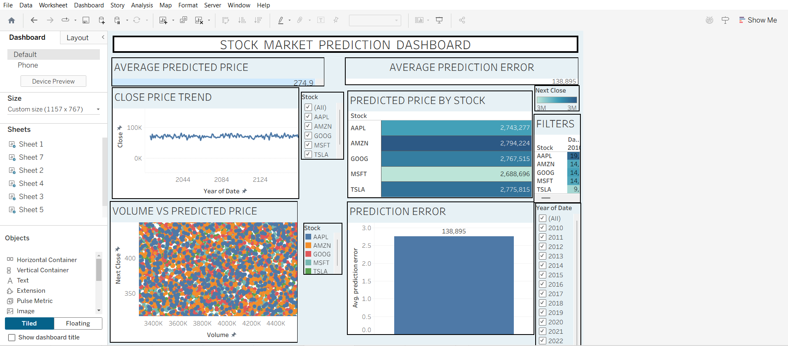

Part 2: Working with Power BI
- Open Power BI Desktop and import the same dataset.
- Explore the Interface: o Familiarize with Fields Pane, Visualizations Pane, Report View, Data View.
- Create Basic Visualizations:
  - Line Chart: Trend of Close Price over time.
  - Bar Chart: Compare Predicted Price vs. Close Price.
  - Card (KPI): Display average prediction error.
- Use Filters and Slicers:
  - Filter data based on Stock Name and Date.
- Create a Simple Measure using DAX:
  - Example: Prediction Error = ABS(Predicted - Close)
- Build a Report Page:
  - Arrange visuals in a single interactive page.
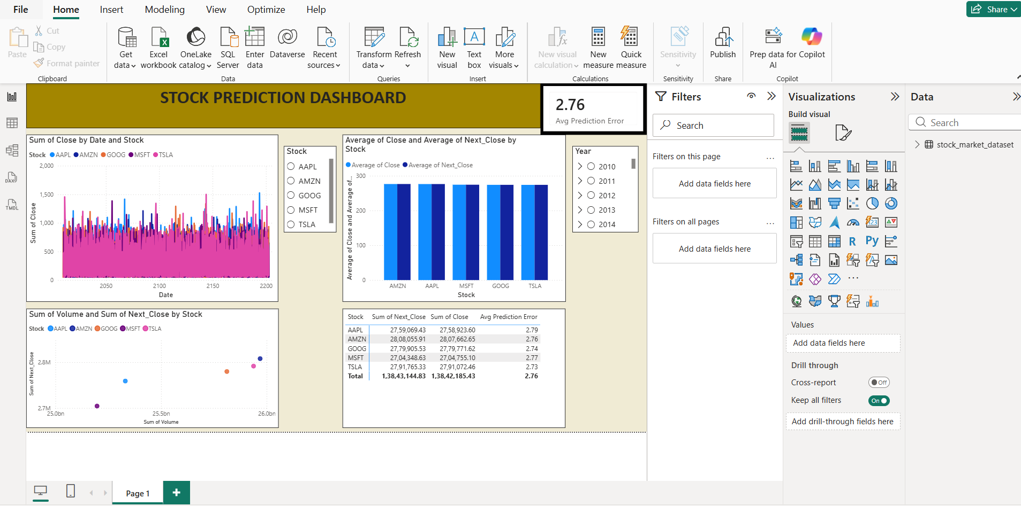

POST-LAB QUESTIONS

1. Describe your experience with the Tableau interface. What components did you interact with?
The interface was intuitive, with drag-and-drop functionality. Interacted with the Data Pane (fields), Sheets (individual visualizations), Marks Card (controls color/size/label), and the Dashboard tab for combining sheets.

2. How did you import the dataset into Tableau and Power BI?
In Tableau: Connect → Text File/Excel → selected the stock dataset. In Power BI: Home → Get Data → Excel/CSV → selected and loaded the same file.

3. What types of visualizations did you create in both tools? List at least two per tool.
Tableau: Line chart (Close Price over time), Scatter plot (Volume vs Predicted Price). Power BI: Line chart (Close Price trend), Bar chart (Predicted vs Close Price).

4. How did you calculate the prediction error, and how was it displayed in your dashboard?
Created a calculated field/measure: Prediction Error = ABS(Predicted - Close). Displayed it as a Card/KPI showing the average prediction error.

5. Which filtering or slicing techniques did you apply, and what insights did they reveal?
Applied filters/slicers for Stock Name and Date Range, which revealed how prediction accuracy varied by stock and time period.

6. Compare the process of creating a line chart in Tableau vs. Power BI. What differences did you notice?
Tableau uses drag-and-drop onto Rows/Columns shelves with automatic aggregation; Power BI requires selecting the Line Chart visual first, then dragging fields into Axis/Values wells. Power BI's process felt slightly more structured/step-based, while Tableau was more fluid.

7. How did you organize the dashboard in Tableau and Power BI? What key elements did you include?
Arranged line chart, bar/scatter chart, and KPI card together with filters placed at the top for easy access, ensuring visuals were aligned and readable.

8. Which tool did you find more user-friendly for financial data visualization, and why?
(Answer based on personal experience — commonly: Power BI is often considered more beginner-friendly due to its structured field wells and built-in DAX measures, while Tableau offers more visual flexibility for advanced users.)

9. What challenges did you face while creating visualizations or dashboards?
Common challenges: correctly formatting date fields, aligning multiple visuals neatly, and configuring calculated fields/measures with correct syntax.

10. How can the knowledge gained from this lab be applied to real-world financial data analysis?
It enables building real-time dashboards for tracking stock performance, monitoring prediction accuracy, and supporting investment decisions through interactive, data-driven visuals.

ASSESSMENT

Description |  | Max Marks | Marks Awarded
Pre Lab Exercise |  | 5
In Lab Exercise |  | 10
Post Lab Exercise |  | 5
Viva |  | 10
 | Total | 30
 |  | Faculty Signature

